Map a Network Drive

To conveniently access a shared network drive, you should map it to a drive letter. The [Credentials & Computer Info](\\\\crmc-san\\groups\\CANCER\\Physics\\Info Spreadsheets) spreadsheet contains a list of drives that you should map. The most important of these are the T: drive followed by the Z: drive. Here is how to map a network drive. The example screenshots show mapping the R: drive.

1. In File Explorer, go to This PC. Your currently mapped drives are listed under Network locations.

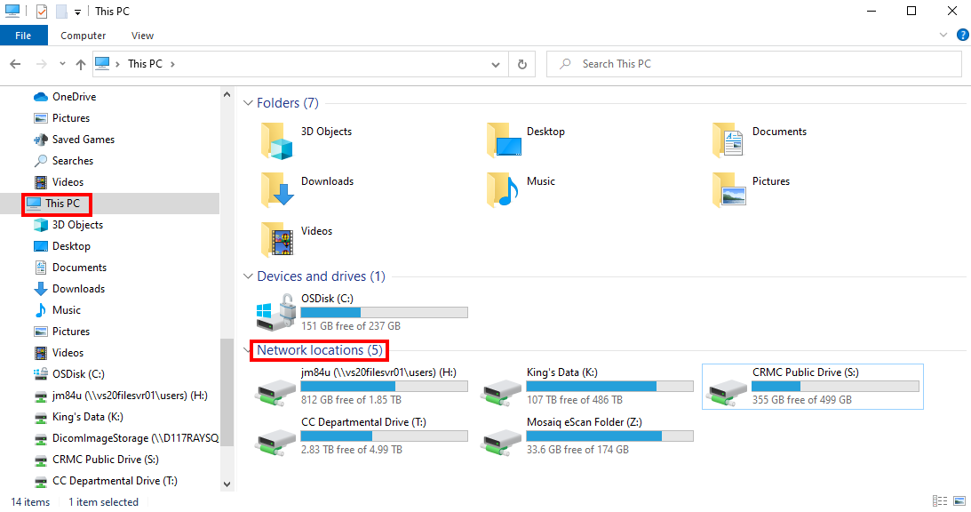

1. On the Computer tab, click Map network drive.

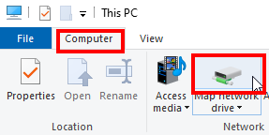

1. From the Drive dropdown list, choose the drive letter listed in the [Credentials & Computer Info](file:///T:\Physics\Info%20Spreadsheets) spreadsheet. (If that letter is currently in use, the drive path is listed in parentheses, and you may not use the same letter for more than one path.)

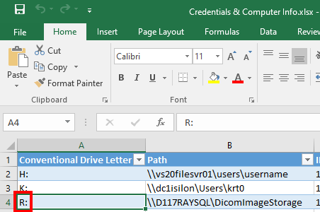

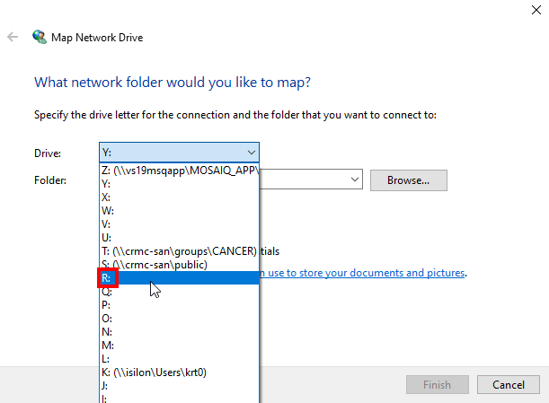

1. Type the network path listed in the spreadsheet, into the Folder box. Click Finish.

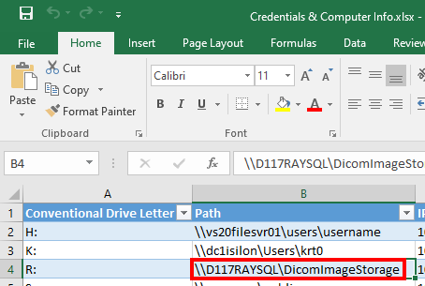

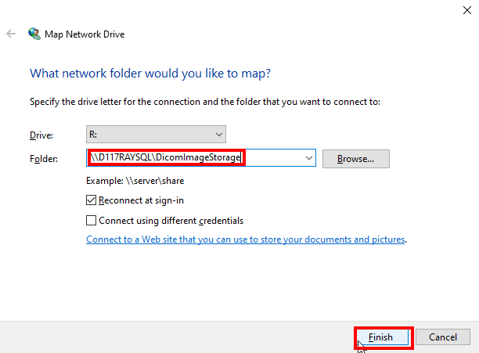

1. The network drive location may open in another File Explorer window. You may exit this window. Back under This PC, you should see the newly mapped drive.

